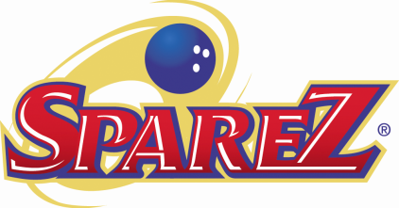
Community Support Program
“Supporting Those Who Serve Our Community”
Our community is supported by a large number of excellent organizations, each dedicated to providing needed service to members of our community. The Community Support Program is one way SpareZ® supports those who support our community.
Each month SpareZ® selects a support organization for a focused awareness campaign with an end of month contribution.
Awareness – The awareness campaign consists of the following:
- Logo Display and message in the large back lit display board at the Customer Service Counter
- Logo Display and message in the PowerPoint rotation on all monitors in the center
- Display of materials supplied by the organization at all service points in the center
Contribution – SpareZ® makes a contribution equaling $.50 for each pair of socks sold in conjunction with the rental of bowling shoes during the month the organization is featured. The contribution is made in the name of the Customers and Staff of SpareZ Davie.
It is anticipated that some organizations will be featured for one month every year. A minimum of four months will be reserved for featuring organizations on a non-recurring basis. The initial schedule is as follows:
November 2012 Bowlers to Veterans Link (BVL)
December 2012 Color Away the Pain
January 2013 Family Central
February 2013 Susan B. Anthony Recovery Center
March 2013 Prestige Club of Broward County
April 2013 Boys & Girls Club of Broward County
May 2013 Big Brothers/Big Sisters of Broward County
June 2013 Juvenile Diabetes Research Foundation
July 2013 Humane Society of Broward County
August 2013 Sheridan House
September 2013 Junior Achievement
October 2013 Pink Jam, Bowl for Breast Cancer

Please submit to Joe, JaNelda or John suggestions for organizations you think we should support through this program.

Joe Schumacker - Schumacker@earthlink.net JaNelda Schumacker – janelda@earthlink.net

John Gullion - jgullion@sparezbowling.com

